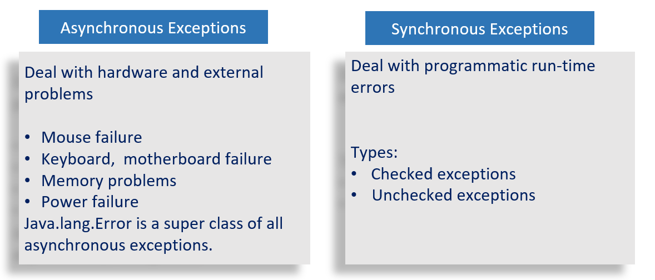

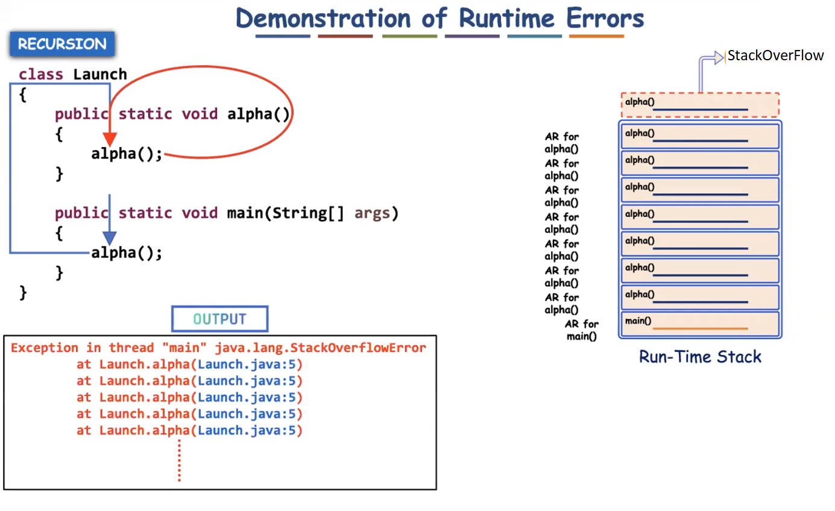

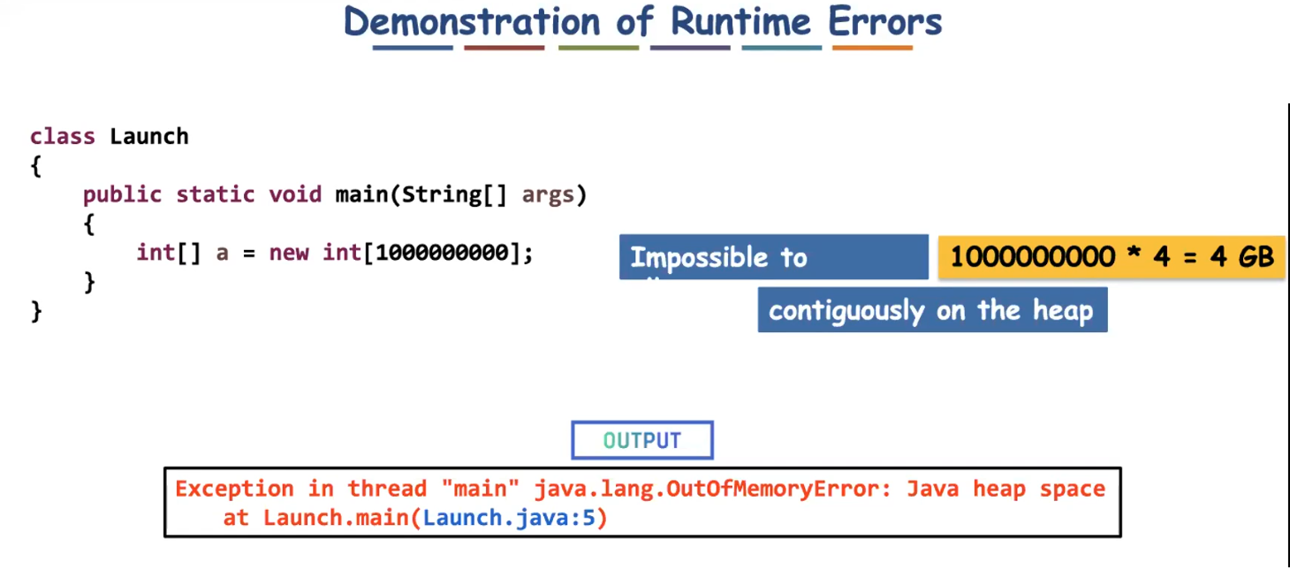

Using if-else avoids the need of exception handling?

No, by using if-else we cannot propagate the problem to the caller. But by using exceptional handling (try-catch) we can propagate the problem to the caller.

Eg: To withdraw money from the atm, we use atm card. To perform any operation with our account, the pin should be given. If the pin is not correct, it says please re-enter the pin.

The machine gives 3 chances to enter correct pin, even after three chances the wrong pin is entered, the account will be blocked.

here user entered wrong pin, so it can be treated as an exception, and it is propagated to the bank server and his account has been blocked. even if he uses other atm he can’t access his account.

If-else can’t propagate that message (wrong input by user for 3 times in atm) to the server, to block his account.

So if-else can’t replace exception handling. (There are some other reasons why it can’t be replaced go through the internet for extra information).

Custom Exception:

Eg: Custom_Exceptions

To write any user defined exceptions we need to extend java Exception class to our user defined exception class.

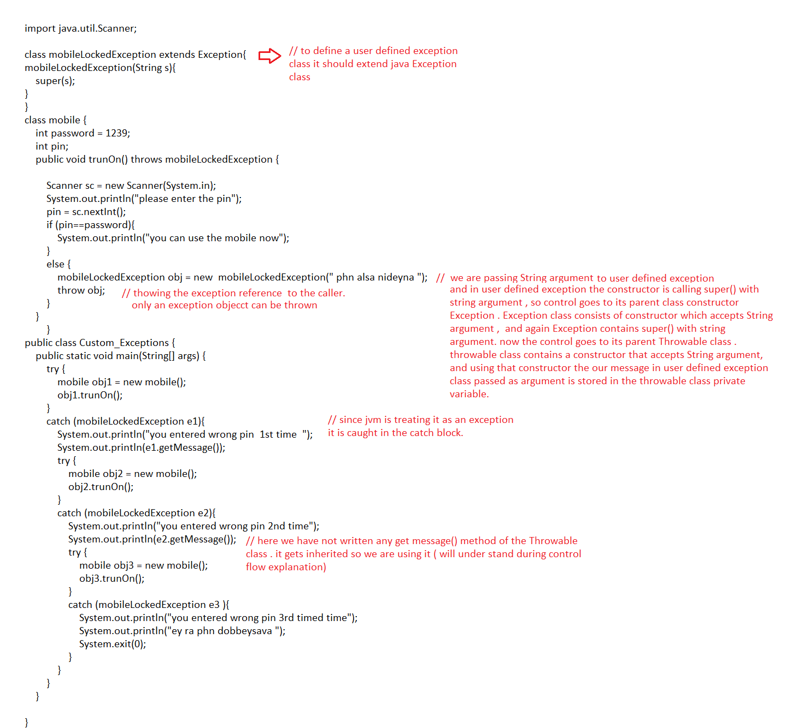

Control flow :

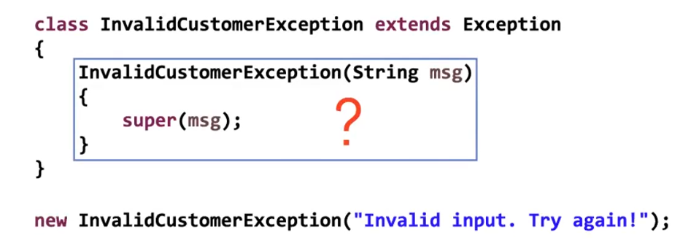

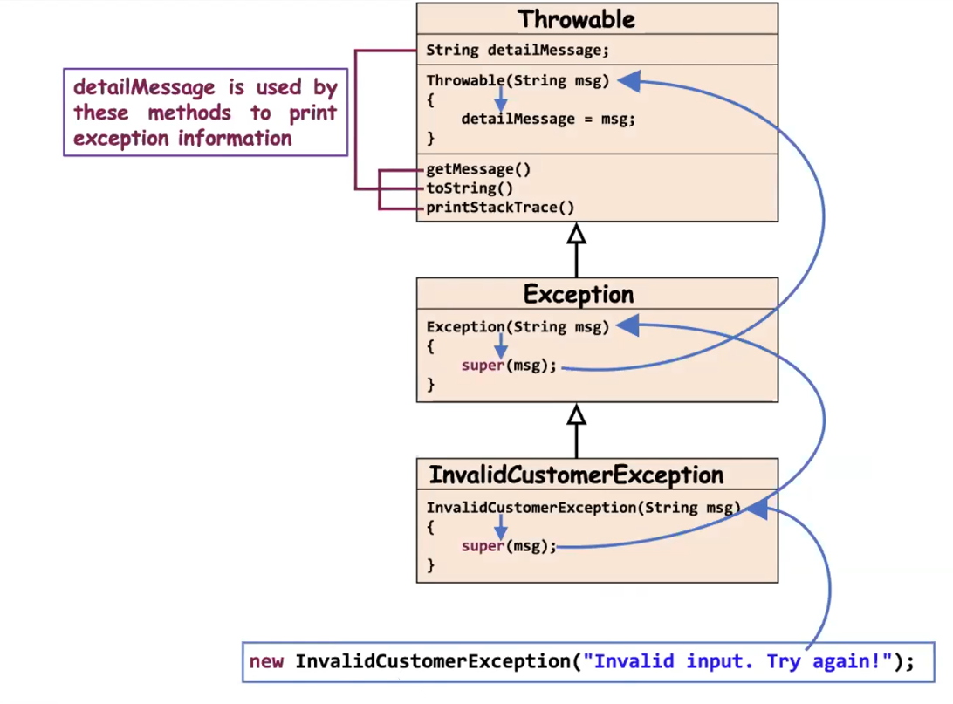

Eg: Exceptional_Handling_Eg9

If some exception occurs during initialization then it is called ExceptionInIntializerError

Static block is used to initialize the static variables. But when arrays are declared default values are assigned , values will be assigned to it only when the object is created. Which leads to exception ExceptionInIntializerError

Eg: Exceptional_Handling_Eg10

// go through the code

Eg: Exceptional_Handling_Eg11

// go through the code